Accompanying words to “Visionaries (final extended version)”
By Esteban Hernández Parra
As I wrote these words, the students of the academy where I taught were performing their final online concert. At that moment, I am drawn by the image of a young violinist performing in a church with a masked piano collaborator in what looks like an empty sacred space. They recorded Piotr Ilych Tchaikovsky’s violin concerto and the violinist is playing it from memory. It seems like the written score we academic “classical” musicians rely on, is proudly missing…
- It seems like performing from memory is considered a superior ability.
The virtual meeting host keeps muting -silencing- the people who join the call in an effort to keep this sonic space focused on those presented as the performers…
- “Turn on original sound when you play” as a requirement to search for an idealistic aesthetic perception of enhanced listening.
We, the audience, are also asked to turn off our cameras for the internet connection to improve for those performing live from their homes
- They momentarily lose our visual presence.
Aren’t these three directives/practices resembling the performance experience of a blind musician?
The program consists of “standard repertoire” (mostly music from white European composers from the past centuries) organized by a careful categorization around ‘level of difficulty’ regarding the physical skills required to perform each piece. I have mixed feelings of admiration for the students’ (mostly) self-regulated learning process during a pandemic, and discomfort when realizing I am participating in the perpetuation of a dominant, colonialist, and privileged perspective around excellence in music making.
Those feelings remind me how grateful I am to have allowed my body to listen with Angélica, enabling my flesh to vibrate with our sounds. My colleague and friend, Angélica María Pico Castillo says she has been making music for 12 years in Colombia and hopes to continue her education in music through the institutional accommodation of her blindness, we have both been searching for a redefinition of the structures of inclusion in sound-making in our country from the perspective of our different conditions.
Throughout this accompanying text, I will ask you to follow your intuition, listening for emotion in Angélica’s voice while reading the passages that I have decided to either translate to English, write in a mixed language (the so-called “Spanglish”) or in Spanish. As a sort of performative “accessibility device” for the readers who do not speak Spanish, I have organized the paragraph structures according to the acoustics of the piece (aligned to each side of the page, as a textual reference of the stereo effect). At some point, inspired by Dylan Robinson’s critical listening positionality (2020), I will also ask for your complicity in performing an integrated sensorial passage through sound and text: not searching for meaning around the final part of the piece (a sort of experiential cluster of not-making sense(s), and remaining open to our ability to “listen otherwise”.
Gracias a Angélica, Andrés, Valentina, Johanna, Majo, Amelia y Arlyn, nuestro Grupo de Investigación me llena! Thanks to Joe, Ezgi, Suyash, Kennedi, Dr. Graper and all my colleagues and teachers whose ideas and suggestions I have embraced full of gratitude!

Please listen with headphones if possible, and read following the duration of each excerpt if you are able:
Narrativa: Aural spaciality, escrita y en escucha to positionarse in el world.
(Minutes 0-0:40) Composing/rehearsing through an online call, Angélica está cansada…
I wake up eager to remember. Trying to record fragments of a song that just came together in my dream. A sort of bambuco (Afro Colombian musical genre) seems to be waking me up to remind me of parts of my identity that carry a need for enacting accessibility and inclusion in my sound.
Una especie de bambuco como sueño de identidad, accesibilidad e inclusión. Despierto tratando de recordar, los sonidos con los que crecí ahora parecen más míos. El mismo género emblemático de un mestizaje violento que, como música nacional, representó una normalización de la inequidad racial en Colombia (Ochoa Gautier, 2014), ahora me busca en sueños de nostalgia y acción.
“But what I find more significant than the bambuco’s never fully accomplished whitening through the ideal of a proper musical mestizaje, is the need for creating a unified genre (air) that could express the unity of the (national) soul” (Ochoa Gautier, 2014, 94). This dichotomy between the discourse of unity from the Colombian nationalist project and the violent racial categorization (Black, Indigenous and White) led to a regionalization of access within the Colombian peoples, affecting their right to live a dignified life and perpetuating stronger divisions among bodies. Angélica and I, having grown in such strong regionalist dynamics, find hope in focusing our musical interaction around a sort of bambuco that communicates our exhaustion from the ways music is taught in academia, through this critical approach to the relationship of racialized and functionally diverse bodies and access in music, we pretend to challenge the alleged “unity of the soul” of bambuco, and propose an acategorical distinction of our bodies and identities towards inclusion (Crawley, 2014).
We are both able to explore making music together, thanks to the unique sensorial abilities our bodies possess, and, in the same way, we should both be able to access higher education at our national public institutions. This is not to overlook our physical and racial differences (we both identify as a functioning mestiza(o), but to acknowledge them and search for ways in which we can harmonize the sort of ‘bodily regionalization’ that represents a disabling distinction when it comes to access formal academic higher education in Colombia.
(00:40-2:03) “The education for a person with disability in Colombia is not transparent, it’s superficial”- transduced melodic a-synchronicity: Trust and support in realizing one’s own teaching potential
Recuerdo cómo hace un tiempo me decía que no le gustaba escuchar su propia voz. Hoy Angélica la utiliza para hacer valer su derecho a la educación, comunicar su inconformidad con el sistema y proponer una nueva forma de hacer música. Reconocemos los aportes de cada cuerpo en el proceso de aprendizaje, con la intención de diversificar nuestra práctica musical a través de fenómenos sonoros multisensoriales (Eidsheim, 2015), que se informan mediante proceso de equivocación mutuo (Ochoa Gautier, 2014) y no se encasillan en definiciones de género o estilo.
As Nina Sun Eidsheim highlights, the academic tendency to favor the epistemological over the multisensorial perception of the sound phenomenon, has limited learning to fixed notions of pitch, duration, form, and genre (2015). Those rational notions constructed over imaginaries of “able-bodied” perceptions have shaped the socially accepted aesthetic and continue to leave out other ways of learning to perceive the world.
Angélica uses the words “transparent” and “superficial” when describing her experience with education in our country, both terms carry visual and moral interpretations that are ironically transduced to our creative process when we communicate about the qualities in our viola sound. When rehearsing the unison section of our composition over an audio call (1:09), we both seem conscious of the delay in our sonic perception due to the physical distance that is being bridged over by the internet and our devices, this forces us to imagine the synchronicity at the other end of the call by sustaining what we would define as the total opposite to a transparent and superficial sound. We are “thickening” the sonic event to demystify the issues of accessibility that some pedagogues would deem inherent to the digitally transduced sounds in our collaboration. We are connecting our sound making to our demand for attention to otherwise possibilities (Crawley, 2017) in learning from the difference in our educational institutions.
“El discurso de la inclusión inscribe el cuerpo social de la discapacidad como una minoría […]. Se construye identidad en la discapacidad, no para devenir otra cosa, sino para ser minoría y poder compartir el territorio con la mayoría.” (Bermúdez Jaimes, 2020, 204-205). Este reconocimiento y expansión de comunidad como resistencia a la discriminación aparece dentro de las “posibilidades de otra manera” (Crawley, 2017) que surgen al reunir cuerpos e ideas diversas convergiendo en el compromiso de construir una pedagogía accesible e inclusiva. Se busca generar interacciones encarnadas que “difieren de la corporalización siendo el movimiento hacia, y la vibración de, la liberación, en vez de presumir ser un objeto de la teología, filosofía e historia.” (2017, 6)
It is searching for “otherwise possibilities” (Crawley, 2017), our Grupo de Investigación invites people from various musical backgrounds to collaborate in a recording project, challenging the traditional way of teaching and learning “academic music” by refraining from graphical inscriptions other than the use of the Braille Music system. We are inviting musicians to be aware of other ways of learning and making music, as “playing by ear” and improvising from memorized melodic contours.

(2:04-3) Vocal count off as characteristic of música popular - acceptance in professional and academic world?
Caí en cuenta de lo que se sintió como treason to my father. En mi afán de synchronize the audio recordings, usé mi voz como evidencia de un 6/8 meter in a bambuco, which “correct” notation would be in ¾. Evidencia de un “acoustic assemblage [which] impl[ies] a mutually constitutive transduction de nociones del sonido como nociones de quien escucha, así como potentially transformative processes of inscriptión del sonido que interrelate listenings and objectos sonoros”. (Ochoa Gautier, 2014, 23)
What happens if I count out loud before one of my doctoral viola recitals? ¿Estaría usando mi voz para romper con las convenciones de la performance etiquette? ¿Qué tan incómodo sería transmitir un mensaje de rupture of the academic/popular dichotomy in a traditionally academic setting?
¿Por qué no soy aceptad@?
Angélica tuvo la valentía of saying the words I have been callando for so long. We cannot allow the continuous de-humanization of our performance by not using our voice, as Mladen Dolar posits, abrazar la voz como el link that une al body to the signifier: “the silent sound, la voz insonora” (2006, 17)
“¿Is it because of intonation?” El tono usado to convey meaning, que puede ser estudiado but is empíricamently perceived. A “good playing” validates our visual conditión?

(3:16-3:36) Braille music, slate and stylus sound, touch y la technological reaffirmation of apoyo.
Let me use this space as a resting point. Los materiales y métodos que utilizamos para grabar nuestra invitación pretendieron ser los más accesibles que conocemos.
We used free software: ZOOM videoconferencing, WhatsApp messaging and audio calls, Audacity and Voice Recorder Pro audio recording. Angélica utilizará Ripper y Guitar Rip para editar la grabación final.
We aim for continued awareness about our privileges in having access to technologies: eyeglasses, JAWS, Simbraille, and VoiceOver software, musical instruments, and headphones to record. We are grateful for this and hope to contribute to the development of more affordable software and hardware to emphasize accessible experiences of artistic expression through our cellphones and personal computers. I have included some of the electronic voices that we are now used to hearing in our interactions as a recognition of the technologies that we use to connect. We want to make part of an informed and proactive community of blind+seeing+visually-impaired people who can overcome the limitations of cellphone software and (more recently) cloud storage management that can “lead to significant social exclusion” (Goggins, 2005, 383).
(3:37-6:42) Invitation: Opening the creative process of composing a song as a mutual equivocation process, using acoustic assemblages that allow a mutually constitutive transduction (Ochoa Gautier, 2014, 23-24)
Objetivos del Tesimonio sonoro: Atención a la problemática, sonidos y creatividad ¿Es nuestra academia para personas “capacitadas”? Is the goal to make us all able?
Excelencia: Redefine the product as a “mishearing of song”, trascendiendo la history of Bambuco inscription in Colombia.

(6:14-6:42) Reimagining categorization: seeing+blind+visually impaired/personas con discapacidad visual+videntes+ciegos. “+” as acknowledgement of difference and harmony, not merging (Robinson, 2020)
(6:43-9:04) CLUSTER
(I now ask for your complicity in a participatory listening experience, in this moment we are making music together, allowing the integrated sensorial experience to override the search for significance/Ahora pido tu complicidad en una escucha participativa, en este momento hacemos música juntes, permitiendo que la experiencia sensorial integrada sobrecargue la búsqueda de significado)
Take a cloth (or any otro textil you can usar as a platform), put a (preferiblemente recyclado) sheet of papel on top of it, and hold a pen(cil) in your hands (con lápiz(cero) en mano). Play. Listen, type as you feel, with the rhytmo of your sonic experience.
When you feel the sonidos we clustered end, turn the página around, close your ojos, and usa tus fingers to sense the rhythm as we concluímos making música together.
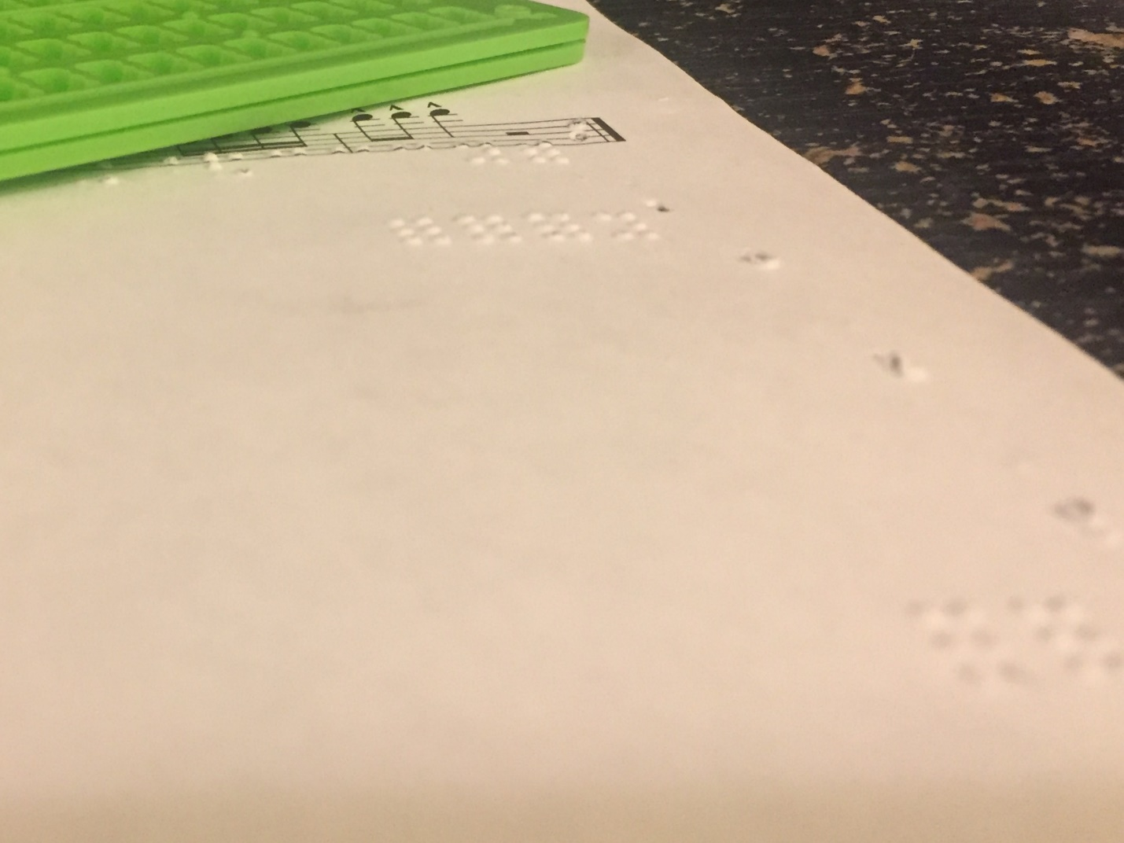
(9:04-) Visionaries
Estamos determinados a seguir aprendiendo alrededor de la inclusión y accesibilidad: the name we proponemos for our collaboración es “Visionaries”, precisamente por que buscamos acoger los aportes creativos de todas, todes y todos.

Sources of inspiración & ideas…

Nina Sun Eidsheim, “Sensing Sound: Singing and Listening as Vibrational Practice” (2015). Duke University Press
Ana María Ochoa Gautier, “Aurality: Listening and Knowledge in Nineteenth-Century Colombia” (2014). Duke University Press
Ashon T. Crawley, “Blackpentecostal Breath: The Aesthetics of Possibility” (2017). Fordham University Press
Gloria Isabel Bermúdez Jaimes, “Corporalizaciones de artistas con discapacidad como resistencia al cuerpo normativo. (2020) Nómadas No. 52 (198-211)
Mladen Dolar, “A Voice and Nothing More” (2006). The MIT Press
Gerard Goggin, “Cellular Disability: Consumption, Desingn and Access” (2005). In “The Sound Studies Reader” Ed. By Jonathan Sterne. Routledge
Dylan Robinson, “Hungry Listening: Resonant Theory for Indigenous Sound Studies” (2020). University of Minnesota Press
“Blindness and vision impairment”, The World Health Organization. Available at: https://www.who.int/news-room/fact-sheets/detail/blindness-and-visual-impairment
“Simbraille font software for Windows”, The Shodor Education Foundation Inc., available at http://www.brl.org/simbraille.html

