“Santiaguito” is a pasillo chocoano originally performed by Tanguí Chirimía, an Afrocolombian ensemble with over two decades of artistic career. The instrumentation of Chirimía in the Chocó region includes voice, clarinet, saxophone, bombardino, tambora, redoblante, and platillos (Valencia, 2009). The version we performed with Bridges MAYO in Bloomington was a string orchestra arrangement by Prof. Leonidas Valencia with edited parts by Sarah Maggie Olivo. Leonidas’ work as an Afrocolombian musician, researcher, and activist, makes otherwise possible (Crawley, 2017) to share the love, resistance, and sense of belonging that Norberto, Santiago, and Tanguí Chirimía put into “Santiaguito.”

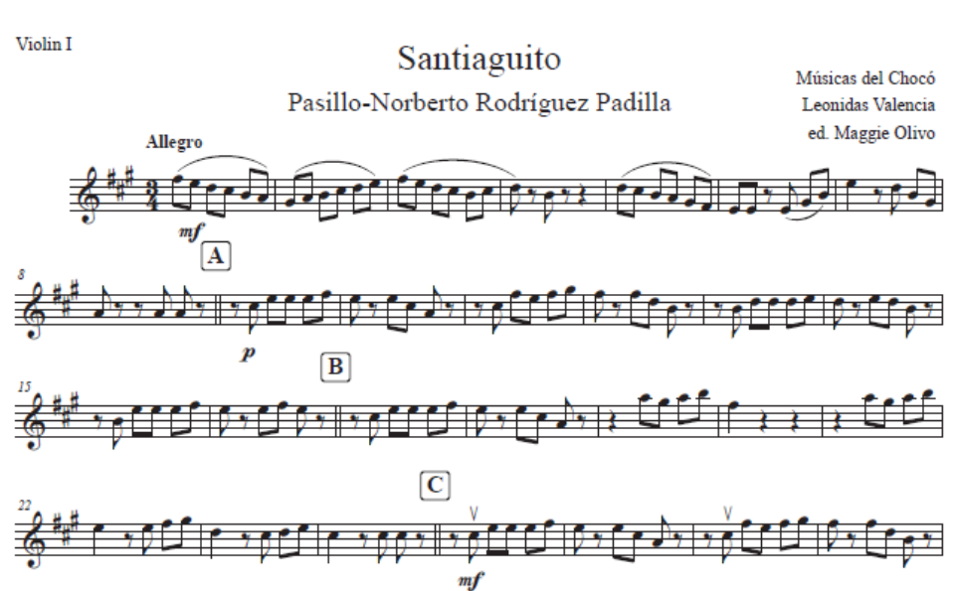
Example 4. “Santiaguito,” edited violin I part with rehearsal letters, suggested bowings, articulations, and phrasing.

During the Bridges rehearsals, one of the academic+oral resources I used, was to draw a parallel between the melodic accentuation in ¾ meter of pasillo and its influences from waltz, which is said to be the European ancestor of the genre (see direction drawn on Example 4). Prof. Leonidas Valencia describes pasillo chocoano as “[a] variation of vals with ternary meter [and] accentuation quality in the downbeat, both melodic and percussive” (Valencia, 2021, p.78). The pasillo chocoano is considered an “influenced musical Air” by traditional musicians of the north Colombian Pacific, it differs from other “autochthonous Airs” on having more evident elements of Indigenous and European musics (Valencia, 2009, p. 16).

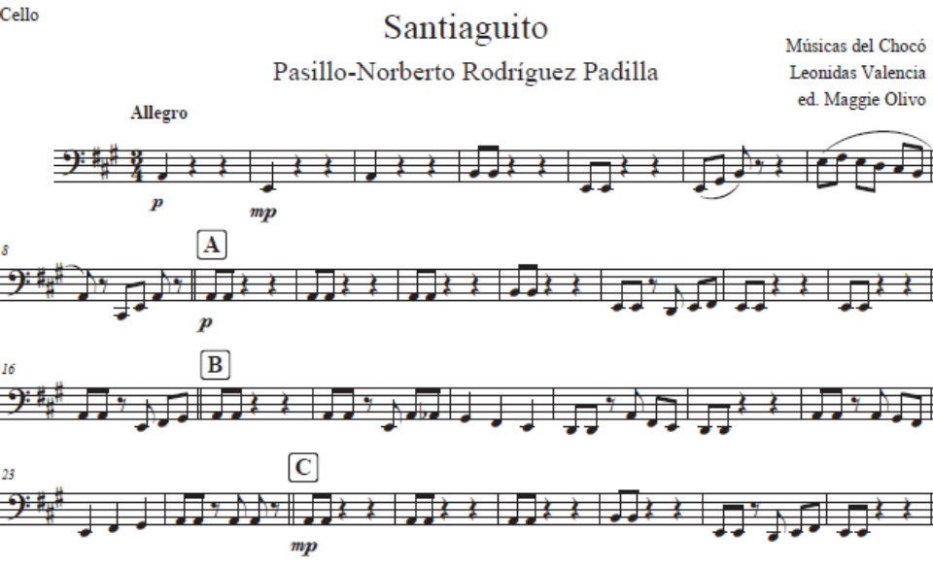
Example 5. Cut-off structure in three-part period pasillo chocoano.

As evident in Examples 4 and 5, Maggie Olivo’s edition of the parts made the arrangement easier to read for our Bridges students, since the KILELE original source only contains the score (see Example 6 below for reference). This is another common resource from the conservatory tradition, which by adding rehearsal letters every set of measures contributes to simplifying the rehearsal process. The visual representation of eight-bar structures between rehearsal letters (see Example 5) helped students distinguish the form and is consistent with the traditional phrasing and cuts of pasillo which “[in] the first period has eight bars with a cut-off, and when three-part, the third period has eight bars with a three-hit cut-off for every period” (Valencia, 2021, p.78).

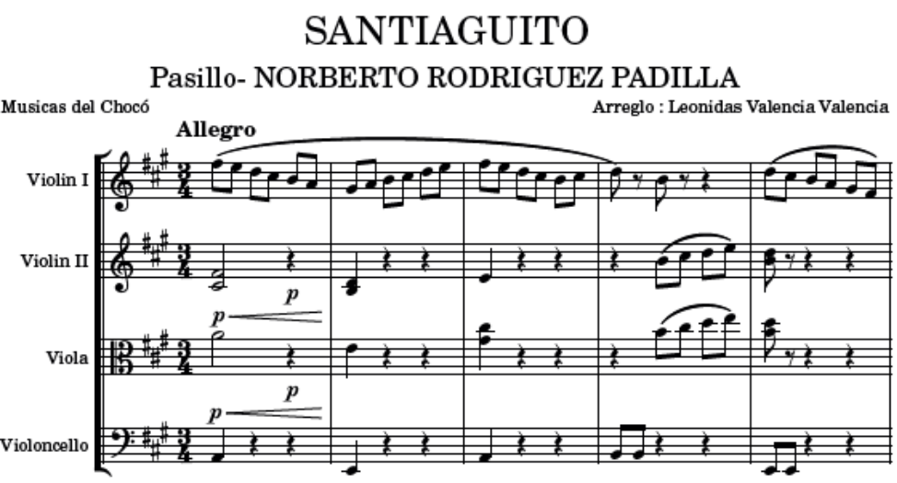
Example 6. Beginning of “Santiaguito” in its original strings arrangement by Prof. Leonidas Valencia. Arrangement and supporting materials available at the RAY website under the pasillo chocoano section in RAY: Bridges plays Colombian musics.

In a different approach than the one I used for my arrangement of the cumbia, explained at the beginning of this chapter, my pedagogical goal with “Santiaguito” was to invite my students to witness a transnational collaboration that required us to go beyond the technical understanding of the form and structures in the genre by focusing on relationality. Experiencing the relevance of sustaining networks of care and solidarity in this Afrocolombian musical practice was central to “making justice” to the piece.
When getting closer to the concert I noticed that even though my students were familiar with the rhythm and melodic structure of the pasillo chocoano, our sound was still far from resembling that of the recordings we studied. We were missing the timbre, cut-offs, and cohesiveness that the percussion gave to this genre. This is when I reached out to Laura Stephany Cohen González, a professional percussionist and Jacobs’ Alumna from Cali, Colombia, whose expertise would help bring the ensemble together. Stephany and I worked through phone calls a couple days before the performance and figured out the main elements of the rhythmic base of pasillo chocoano; we were able to identify three sonorities we could replicate in Bloomington. These were the redoblante, platillos, and tambora, for which we used the bass drum available in our performance space. We did not have a recording of “Santiaguito” available, but through other pasillos recordings on YouTube, we identified the cuts and effects that were common in this genre. Later I found Prof. Leonidas Valencia had published a resource a couple years ago in which he explained the rhythmic base through transcriptions like the one in Example 7 below (Valencia, 2021). The link to this resource will be available at the RAY website along with the materials for “Santiaguito” under the pasillo chocoano section in RAY: Bridges plays Colombian musics.

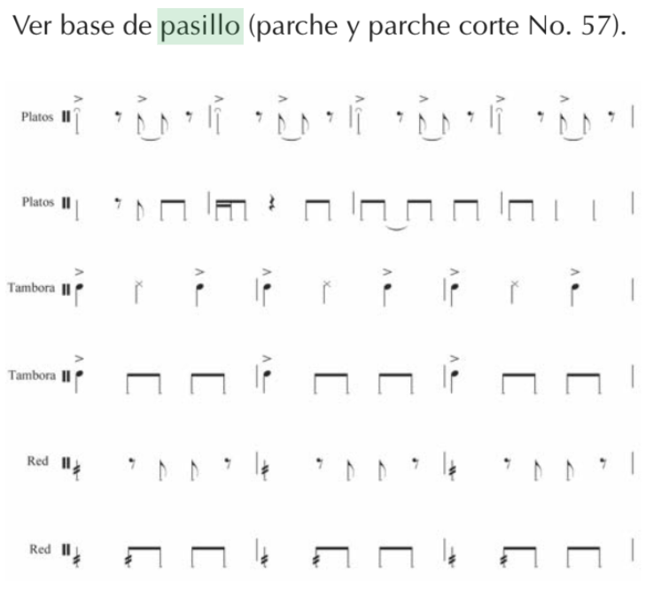
Example 7: Rhythmic base of pasillo chocoano, as transcribed by Leonidas Valencia (2021).

The sabrosura Stephany shared with us through her playing, more specifically, through the timbre, pacing, and cut-offs helped us reinforce our sound, to get closer to what had listened from the recordings of other pasillos by Tanguí Chirimía that we used as reference. This collaboration allowed us to perform beyond bowings, articulations, form, and technical proficiency, prioritizing playing together and communicating our enjoyment of being in a community of care. We were sounding el Vivir Sabroso.

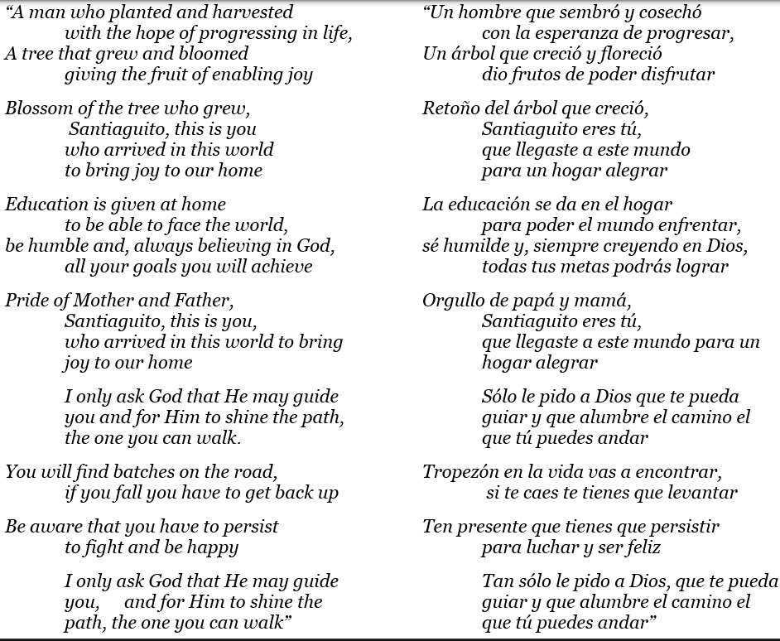
Figure 5. Lyrics to “Santiaguito” by Norberto Rodríguez Padilla with English translation.

This prioritization of care honored the importance of relationality through family love and tenderness, central to Norberto’s lyrics to “Santiaguito.” When listening to the words with the Bridges students, we were resonating with the performance of filial love through Norberto’s voice. Even though our realities are different and our relationships with our grandparents/caretakers might have other expressive dynamics, I sensed we were able to get closer to “listening through sovereignty,” the type of enactment that Dylan Robinson calls for: “we must paradoxically engage a listening that does not reduce what is heard to the knowable, that resists a multicultural categorization of one cultural sound among many, that understands sound in its irreducible alterity, and that moves beyond our recognition of normative musical or performance protocols. Such listening would understand that not all sound can be translated to equivalent analogies” (Robinson, 2020, p.64).
At the end of our performance, and in the continued spirit of listening through sovereignty, we watched Norberto and Santiago’s message as a community, after having performed their piece. Their voices in the hall became testimony of care and a generous invitation to continue musicking with love, joy, and pride.

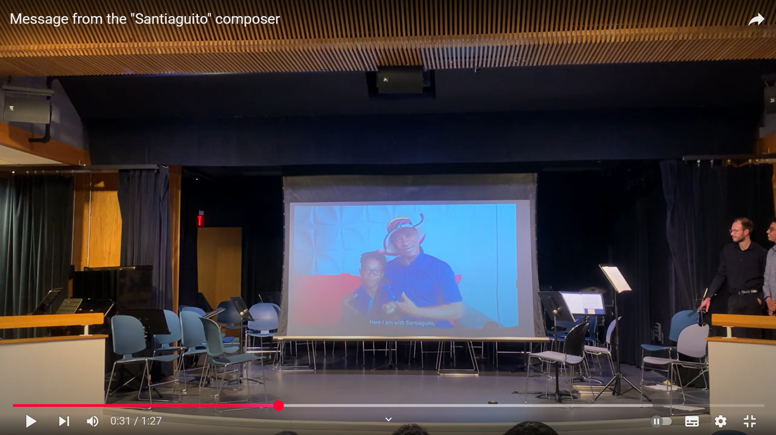
Figure 6. Norberto and “Santiaguito” share a video message for the Bridges students at the Monroe County Public Library Auditorium.

The resources discussed in this section on “Santiaguito,” available at the RAY website under RAY: Bridges play Colombian musics, can be used by educators and performers to contextualize the piece for student populations who have not been in contact with pasillo chocoano traditions. Maestro Norberto has generously agreed to share the materials to teach and perform his music at no charge, his interest is for more people to have contact with his music. The materials to be found online are the complete “Santiaguito” arrangement for strings by Leonidas Valencia with the edited parts by Maggie Olivo, the lyrics in Spanish with English translation, the audio recordings from the composer singing the lyrics and explaining the context, the Bridges video performance of the piece with the introduction by Norberto and Santiago, and the supporting materials for percussion.

In English, bombardino is the baritone horn/euphonium, tambora is a bass drum, redoblante is the snare drum, and platillos are cymbals.

